Title of the abstract (Times New Roman 14 bold)

Firstname Name¹, Firstname Name², Firstname Name ^{1,2} (Times New Roman 12 bold)
¹ Affiliation (Times New Roman 12 italic)
²Follow the example for the affiliation
³Université de Strasbourg, CNRS, Institut de Bioelectrochimie et Spectroscopie de Strasbourg, F-67000 Strasbourg, France
E-mail: contact.author@somewhere.world (Times New Roman 12 italic)

Put your abstract here. The text style should be “Times New Roman, 12” with 2 cm margins top, bottom, left and right. Equations style is to be set to “Times+Symbol 10”. Short equations may appear directly in the text. For larger ones, they should be separated with appropriate spacing and include an equation number (right justified).
${\text{e}}^{\text{x}}\text{=1+}\frac{\text{x}}{\text{1!}}\text{+}\frac{{\text{x}}^{\text{2}}}{\text{2!}}\text{+}\frac{{\text{x}}^{\text{3}}}{\text{3!}}\text{+}\text{…}\text{, -}\text{∞}\text{<} \text{x} \text{<}\text{+}\text{∞}$ (1)
The abstract may include figures. They should be associated with a caption including the figure number (1, 2, 3…) and the description as presented in the sample below. The caption should be inserted using the Microsoft Word caption tool. Select the image and go to the References→Insert Caption option.
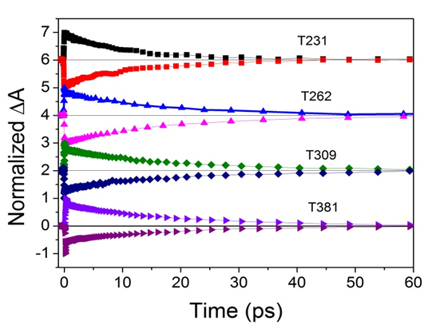
Figure 1. Put the figure caption here. When needed, reference the different elements of the image with letters a, b, c… and put the corresponding description as follows: a) First comment here, b) Second comment here,…(Times New Roman 10)
The figures should be referenced in the text as follows: Fig. 1 or Fig. 1,2... The numbers should be separated by commas without additional space. References should be added manually. In the text, the reference number should appear as an exponent^{[1]} and be delimited with brackets. The references should appear after the punctuation mark.^{[2]} Multiple references should be separated by a comma without additional spacing.^{[1,2,3]} The reference list should appear at the end of the abstract in a section titled References. It should include the author initials and names, the title of the journal (italic), the year of publication (bold), the volume and the page.^{[1]} Separate the different element with comma and space. For books, indicate the author’s name, the title of the book (italic), the publisher, the year (bold) and the page using comma and space separations.^{[2]} For websites^{[3]} indicate the full URL.
Funding should be indicated separately before the acknowledgement. Indicate the funding source and the grant number.

Funding (optional): National Research Agency (12354) (Times New Roman 12)

Acknowledgement (optional): We thank all the contributors for using this template and allow a nice and coherent presentation of the conference papers. (Times New Roman 11)

References: (Times New Roman 12)

- A.-B. Smith, C. Jones, D. E. Doe, F. Others, ACS Nano, 2010, 8, 31415
- G. Dupont, H. Durand, Photochemistry, Springer, 2009, 7184
- http://www.ipcms.unistra.fr/

